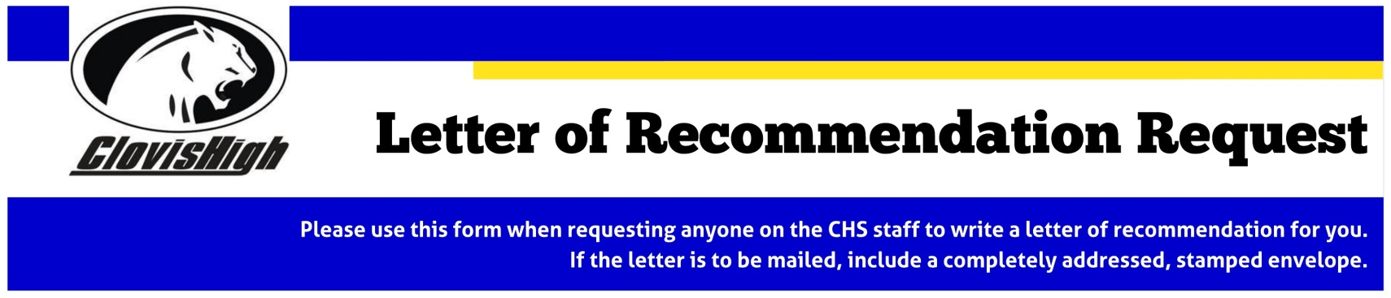

LETTERS OF RECOMMENDATION TAKE 7 – 10 WORKING DAYS TO COMPLETE | Date Needed  (MM/DD/YYYY): | / /

Student Name: |  |  | Student ID:
Ethnicity (optional):
Who will be writing letters for you? Indicate relationship (i.e. counselor, coach, teacher, family friend, etc.).
Reason for letter of recommendation (i.e. scholarship, college application, special award, military)?
Indicate a teacher who can be contacted to offer a personal quote about you.
PERSONAL INFORMATION
List five words you would use to describe yourself. Explain two of them.
Indicate a common experience that you share with the person writing the letter.
What personal qualifications do you want stated about you?
What is something interesting about you?
What accomplishment are you most proud of?
What is your favorite subject? Why?
What is something that most people don’t know about you?
Briefly describe a hardship or difficult problem you have overcome and explain how you handled it.
Briefly discuss leadership skills you possess, organizational skills you used in a project, or skills you possess that others have noted about you.
What other information would you like to include? (i.e. cultural background, outside school interests, activities, hopes, dreams, financial need, things that make you different from other applicants). Don’t be shy!!!
Indicate how your cultural background has impacted who you are.
HIGH SCHOOL INFORMATION
What activities or membership in clubs do you want mentioned? (note leadership roles)
What are your hobbies or special interests? What experiences do you have in 1-2 of these?
What community service have you done? How many hours? (note leadership roles)
What sports have you played at CHS (note leadership roles)?
What honors or awards have you received? Be specific.
AFTER HIGH SCHOOL
What are your plans after high school?
List colleges where you are applying for admission.
What subjects are you considering for your college major?
What are your career goals?
What experience have you had in this career field?

